**Step 1.**

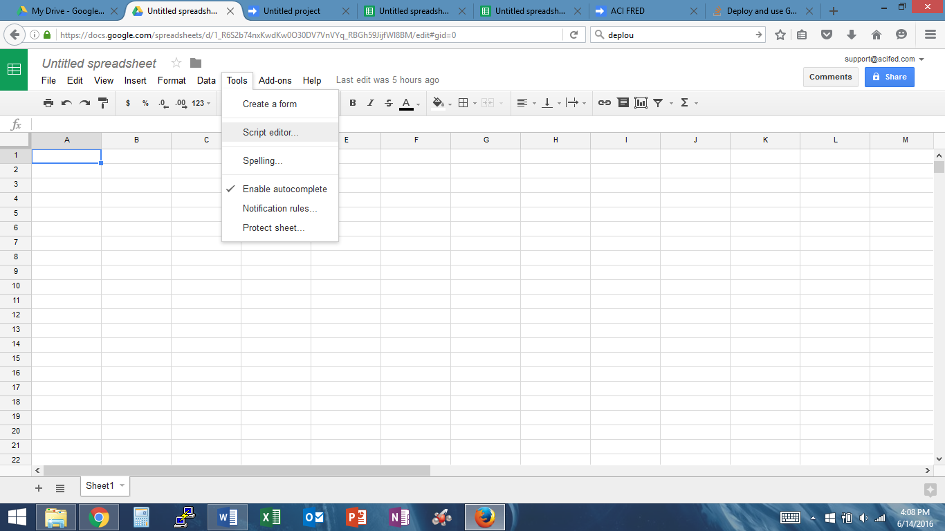

**Step 2.**

Delete everything from the document.

Click on “ACI FRED” Folder > Click on “OnOpen.txt”

Copy all the content.

Paste in the blank document.

Click on File > Save > Name the document “ACI FRED”

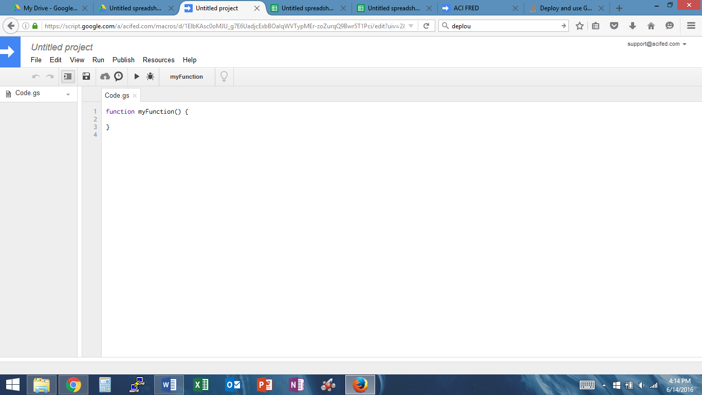

**Step 3.**

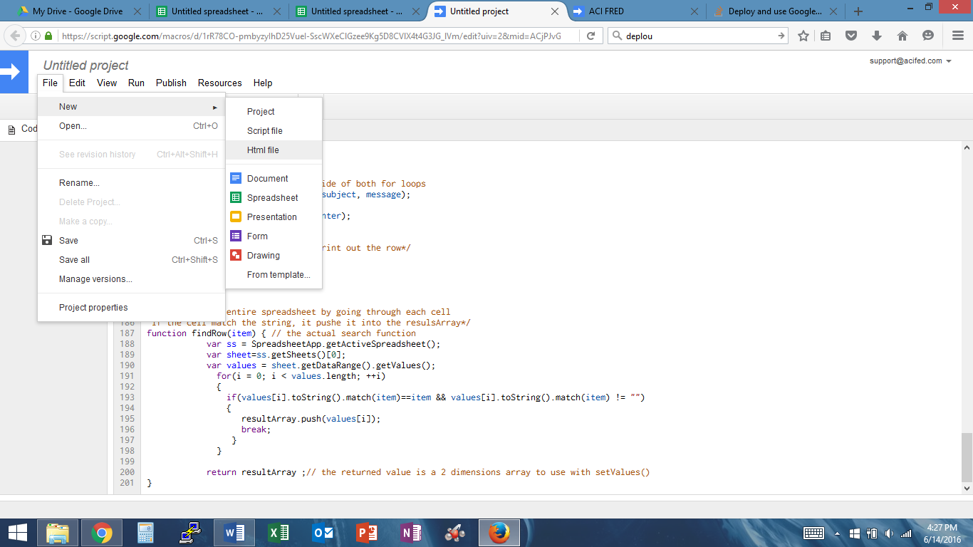

**Step 4**

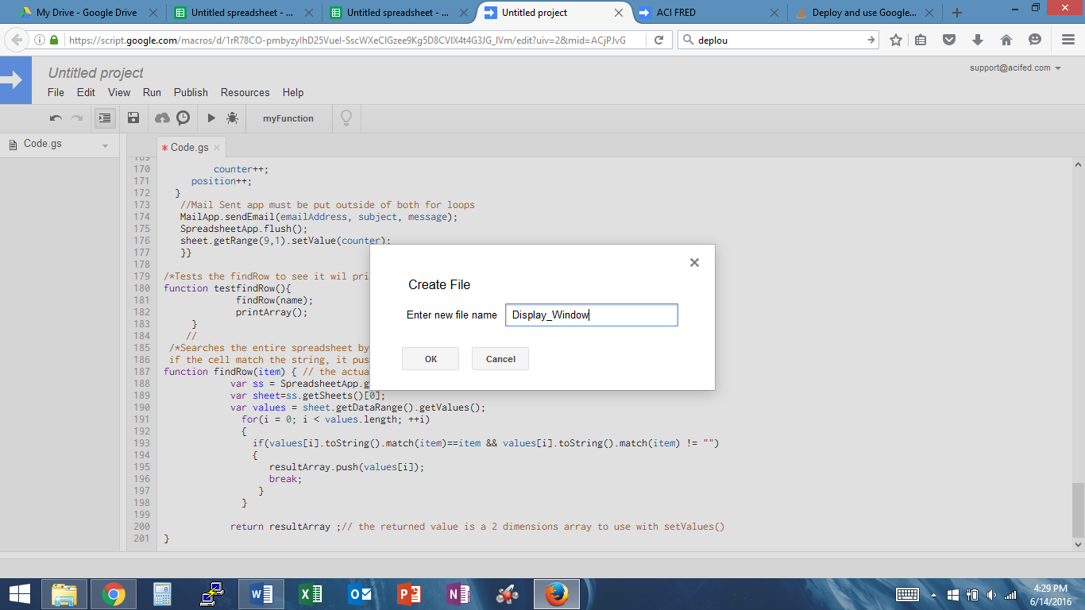

**Step 5.**

Delete everything from the document.

Click on “ACI FRED” Folder > Click on “Display_Window.txt”

Copy all the content.

Paste in the blank document.

Click on File > Save

**Step 6.**

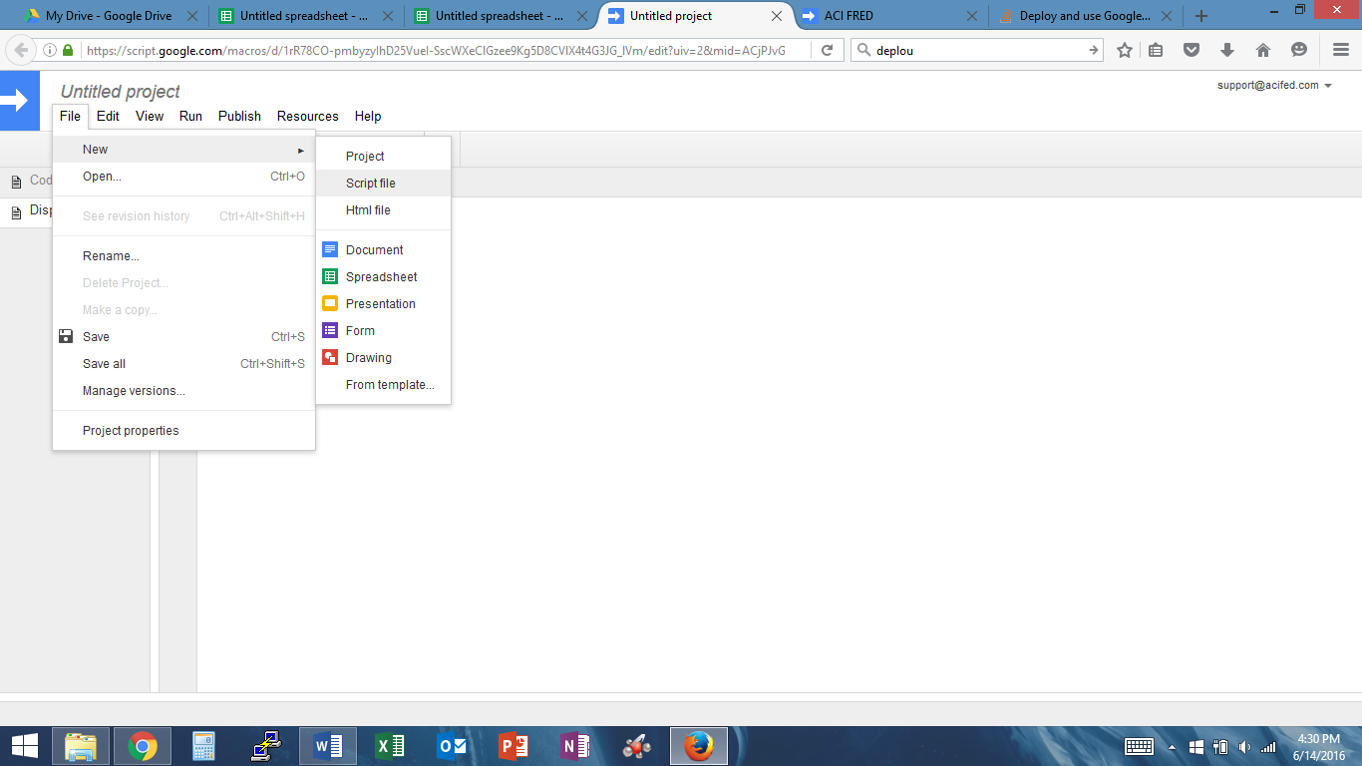

**Step 7.**

Delete everything from the document.

Click on “ACI FRED” Folder > Click on “Text/Email.txt”

Copy all the content.

Paste in the blank document.

Click on File > Save.

**Final Step**

This what should be displayed in document.

